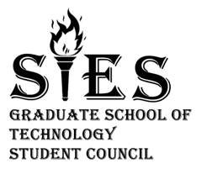

**College Name: S.I.E.S Graduates School Of Technology**

**The Literary Team Presents:**

**Model United Nations (MUN)**

**Promotion offer:**

|  |  |
| --- | --- |
| Database – ONLY FOR FE | RS.4,500 |
| Database 2000 students from all years | **RS.9,000** |